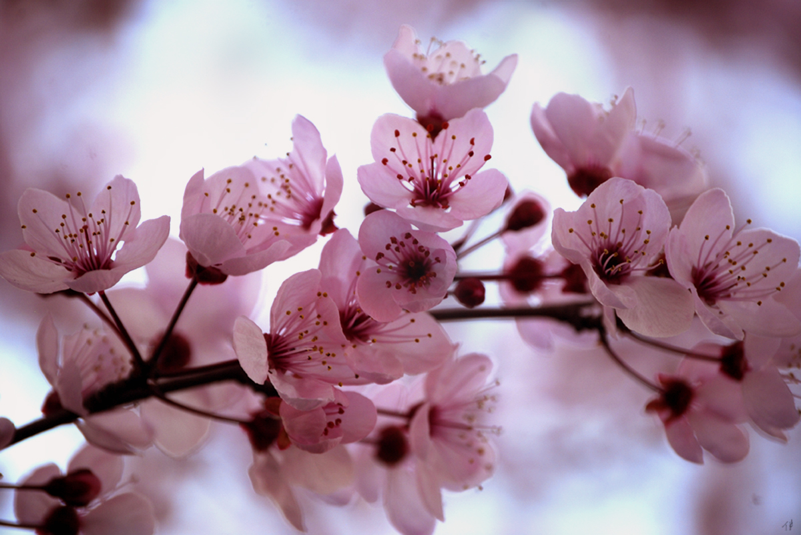

Spring is here. The warm weather has helped the flowers bloom early.

FYI, the link below will give you places to spend a day to enjoy
the cherry blossoms. Don’t be too late because the blooming lasts
approximately two to three weeks.

http://www.shltrip.com/Cherry_Blossom_in_New_Jersey.html

Go and take some pictures. Send OHKA your best shot.

The subject is the blooming cherry blossoms.

Three winners will receive free OHKA memberships for term

October, 2012 – September, 2014 and the photos will be posted on the OHKA website.

Please email one picture per entry with your

name, date and place to OHKA.EMAIL@YAHOO.COM.

Entries are open till April 13, 2012 and winners will be announced on April 15, 2012.

This contest is open to OHKA members and non-members.

