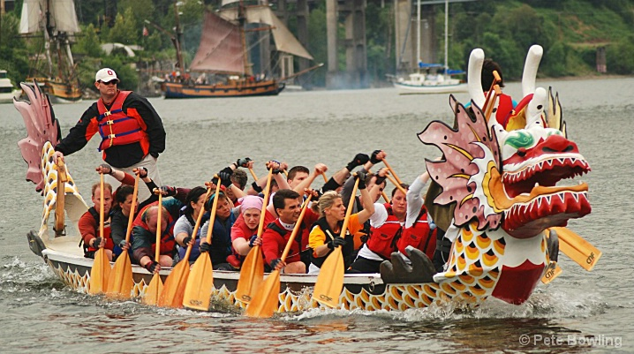

On Sunday, June 3, 2012, the Paddle for Pink Dragon Boat Festival, hosted by the Machestic Dragons will be held at Mercer County Park Marina in Princeton, NJ.

OHKA will not be forming a team this year. You can participate as an individual paddler or form your own team or even if you don't have a full team, arrangements can be made for you.

Below is the link which has all the details about the festival.
www.paddleforpink.org

